MagicPin App – Defect Report

Tested by: Janasi Jaiswal
Email: janasi.jaiswal@coforge.com / 1314jaiswaljanasi@gmail.com
Employee ID: 85010931

Bug 1: Price filter ("Low to High") does not sort results correctly.
Description: On the Home page, applying the "Sort by: Price low to high" option under the Food and Beverages category does not arrange listings in ascending price order. Items with higher "for two" prices appear ahead of cheaper ones.
Steps to Reproduce:
1. Open the MagicPin app Home page.
2. Apply the category filter "Food and Beverages".
3. Apply "Sort by: Price low to high".
4. Scroll through the resulting list and compare the displayed prices.
Expected Result: Listings should appear in strictly ascending order of price for two.
Actual Result: The list shows a mixed order — e.g. ₹80, then ₹400, then ₹80 again, then ₹300, ₹350, ₹150 — which is not sorted.
Screenshot:
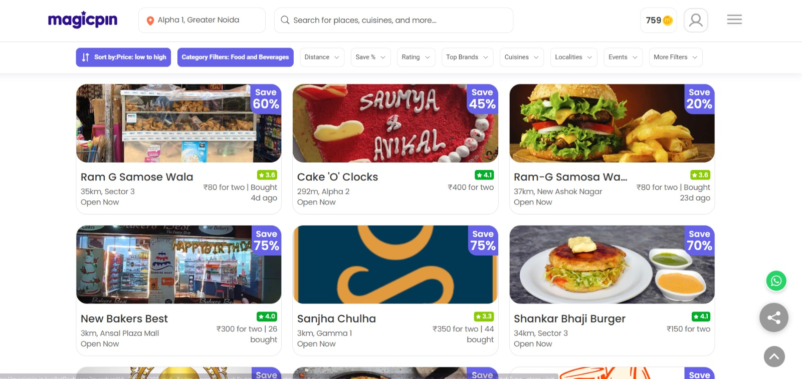

Bug 2: Category filter under "More Filters" does not allow multiple selections.
Description: On the More Filters panel, only a single category (e.g. Pharmacy) can be checked at a time. There is no way to select an additional category alongside it without first clearing the current selection.
Steps to Reproduce:
1. Open the Home page and go to a category listing (e.g. Pharmacy).
2. Open "More Filters" > "Category Filters".
3. Select one category checkbox.
4. Try to also select a second category without unchecking the first.
Expected Result: The panel should behave as a standard multi-select filter, letting the user check or uncheck any combination of categories.
Actual Result: Only one category can be active at a time; other categories cannot be marked until the current one is cleared.
Screenshot:
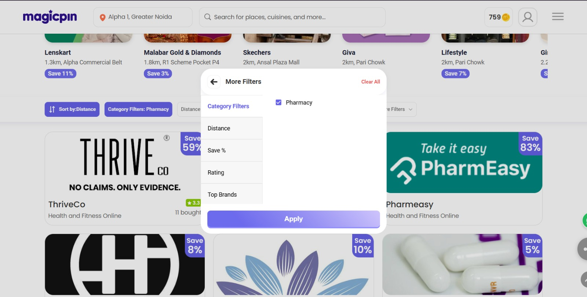

Bug 3: Order/search flow resets the location to "New Delhi" instead of the location already granted.
Description: The Home page does not detect the user's exact location after permission is granted and displays an incorrect location. Furthermore, when searching within the ordering flow, the location resets to "New Delhi" instead of retaining the user's selected or granted location.
Steps to Reproduce:
1. Grant location access and confirm the Home page shows the correct location.
2. Move into the ordering/search flow and search for an item (e.g. "Biryani").
3. Observe the location shown above the results.
Expected Result: The search should use the location already granted on the Home page, not revert to a different default city.
Actual Result: The results page shows "New Delhi" and returns no results, even though the correct location was already granted and shown on the Home page.
Screenshot:
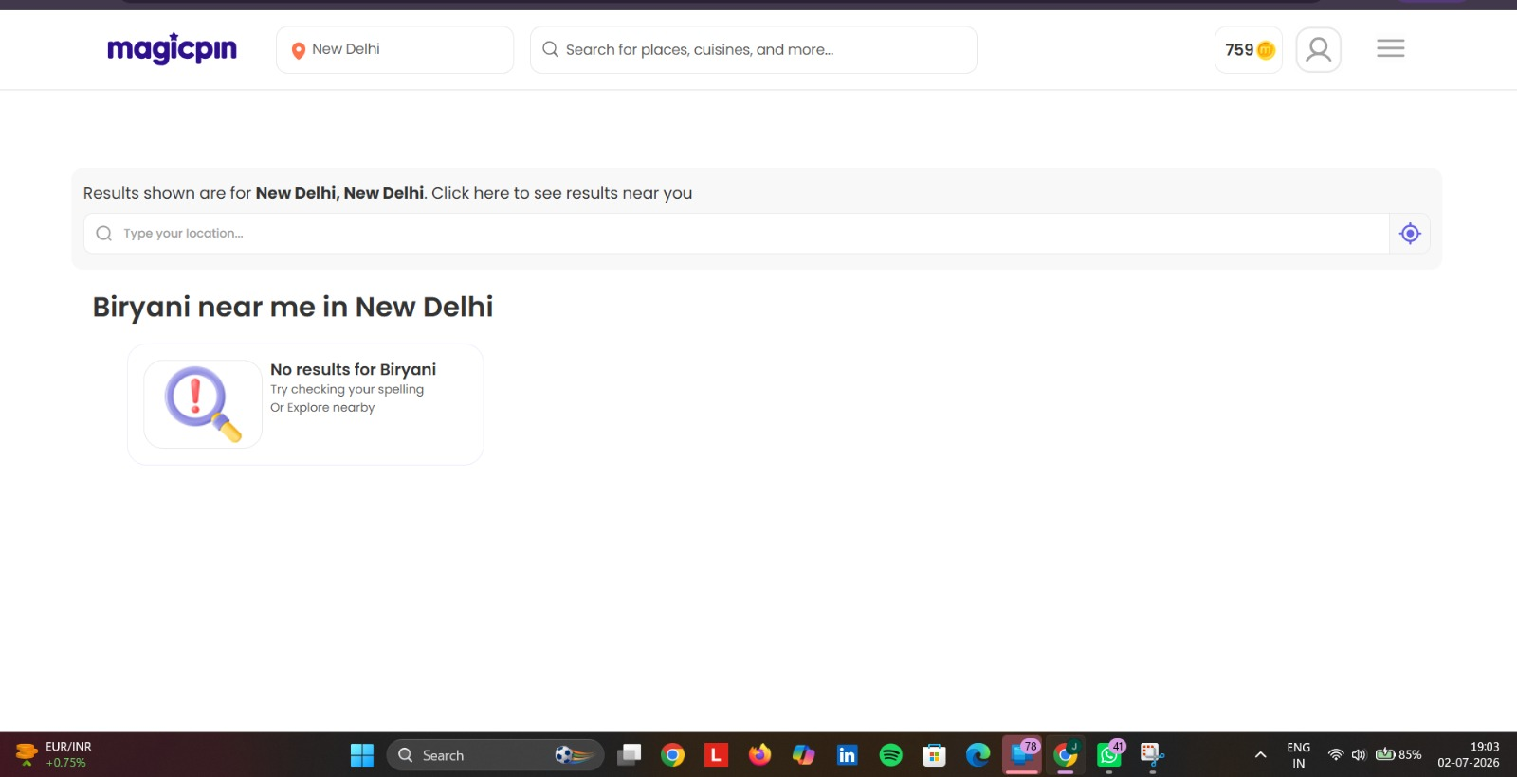

Bug 4: Magic Coins balance shows 0 after navigating away from the Home page.
Description: The Magic Coins balance shown in the top-right corner does not stay consistent across pages. After navigating to sections such as Online Vouchers or Restaurant listings, the balance displays 0 instead of the actual accumulated coin balance.
Steps to Reproduce:
1. Note the Magic Coins balance shown on the Home page.
2. Navigate to the "Online Vouchers" section (or another category tab).
3. Check the Magic Coins balance again in the top-right corner.
Expected Result: The Magic Coins balance should remain consistent with the user's actual balance across all pages.
Actual Result: The balance drops to 0 on the Online Vouchers page instead of showing the real balance.
Screenshot:
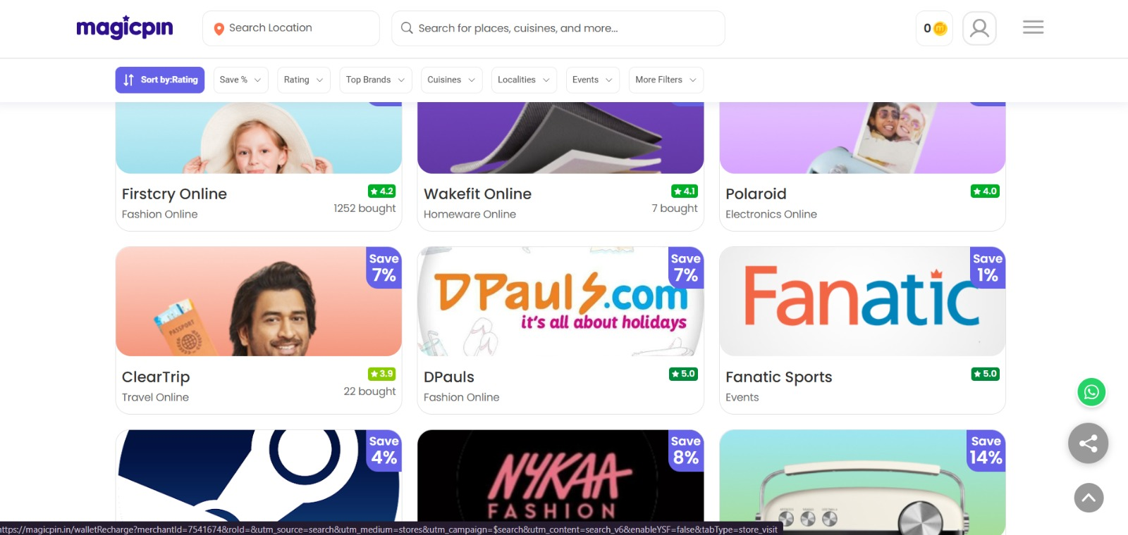

Bug 5: "Around You" / navigation location label shows "Greater Noida" instead of the user's specific granted location.
Description: The location label used in the top navigation shows only the broad city name "Greater Noida" rather than the more specific locality the user actually granted (e.g. "Alpha 1, Greater Noida"), even though that specific location was already detected and shown elsewhere in the app.
Steps to Reproduce:
1. Grant location access to the app.
2. Confirm the Home page detects the specific locality (e.g. "Alpha 1, Greater Noida").
3. Open the top navigation / category tabs (e.g. Restaurant) and check the location label shown there.
Expected Result: The navigation location label should stay consistent with the specific locality already granted, not fall back to a broader city-level label.
Actual Result: The label shows only "Greater Noida" instead of the specific locality that was granted and shown on the Home page.
Screenshot:
